GIT and GitHub

1.check and install if not yet
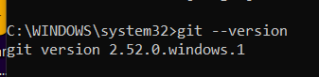
----create a folder
when we want to version control a specific folder we create a folder opne that folder in cmd and do git init
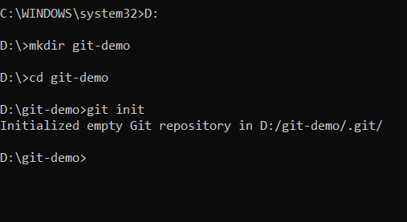

2.git init
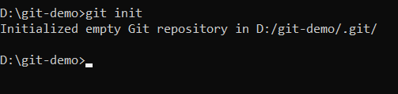

Now open that folder on vs code which u created

3.git status
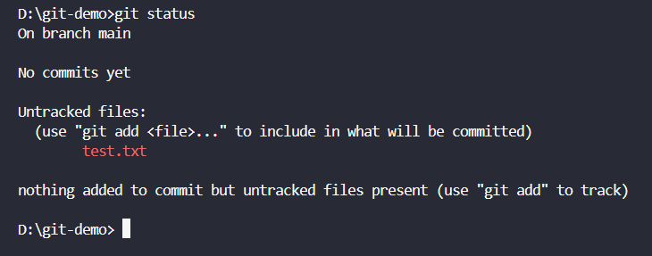

What is branch?
-jaise loki ki timeline
Why we create a new branch?
-main code should not get affected when we are working on a new thing

4.changing the branch
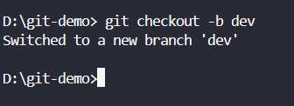

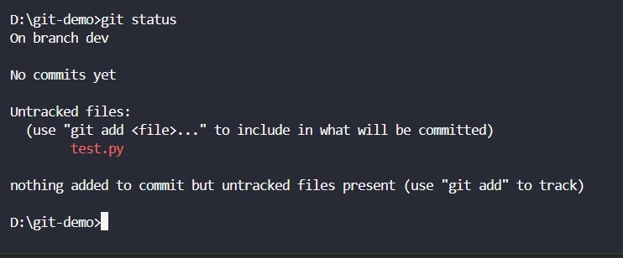
5 to go back to master/main branch
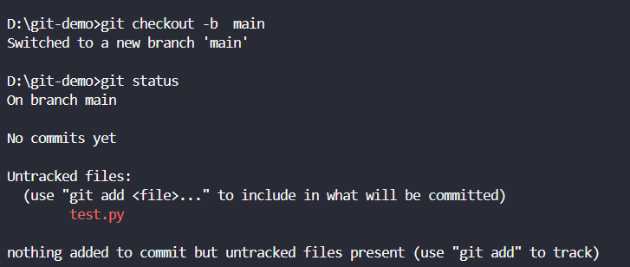

Note:we have no data init so it looks like a new folder

-----commits
1.git add
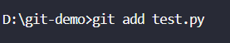
git add . :this is git addd all so its risky cause jo nhi add karna who bh add hi jayega
So untracked files become tracked
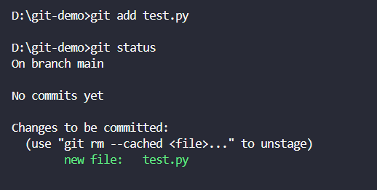

2.now we need to commit
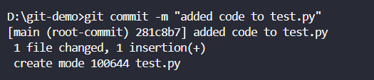

[now all changes will be tracked]

3.RESTORING A file
-delete test .py and see git status
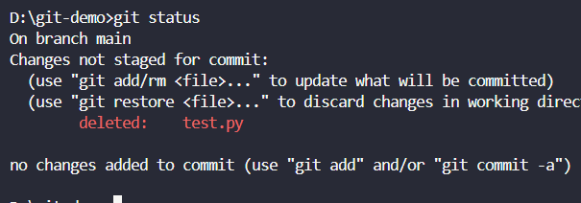
Deleted but not committed so we can go back to it again using this cmd
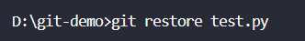

4.suppose u have staged or added 3 files and u want to unstagea file use

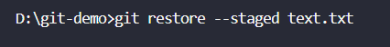
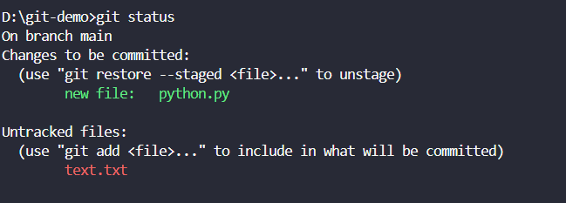

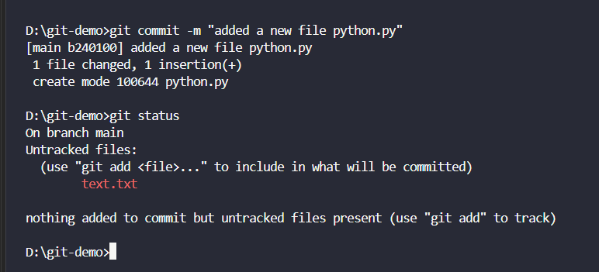

Suppose u have saved 2 files in main /master branch

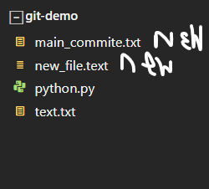

-commit them in the main branch
Do it for bith the new files here I have should only one
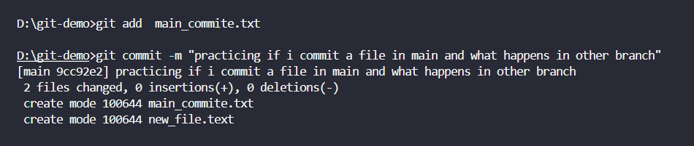

SWITCH to the dev branch
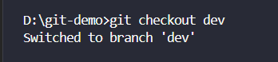

-you will see that those files are not there in dev cause
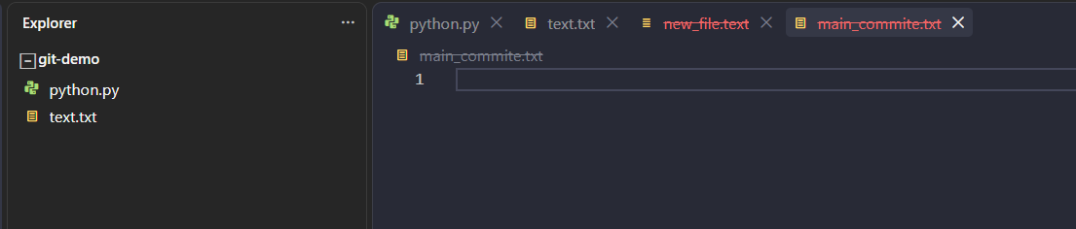
Cause first we created python.py and text.txt and committed them
After that we create dev branch so those files copied there itself
Then return to main and created 2 new files
Therefore these updates are not shown in the main /master branch

Now add a new file whilest in the dev branch and save and commit it (new_dev.txt)
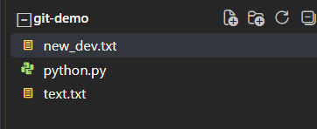

-add and commit in dev
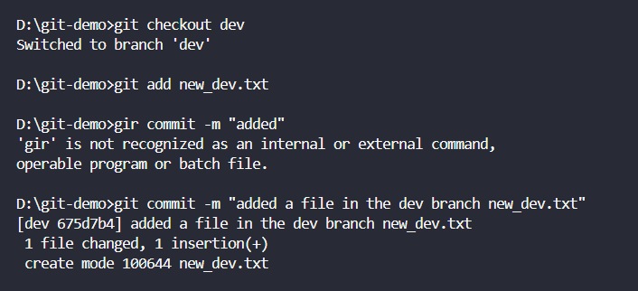

-main will not have it
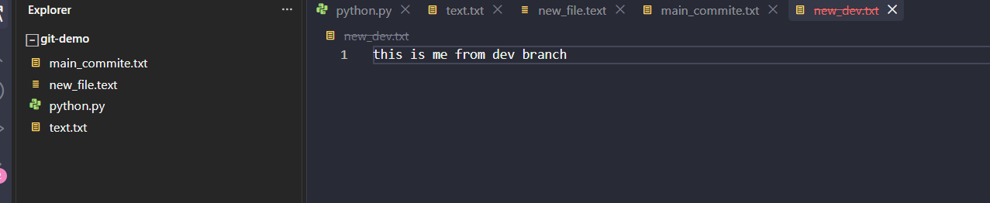

crate file f1/f in main
new branch in dev with same files but if u create f6 file in dev
and switch to main u wont be able to see in main cause its other branch
also if we crate f3 after creating dev dev will not update with f3
cause we created f3 after creating dev

GITHUB
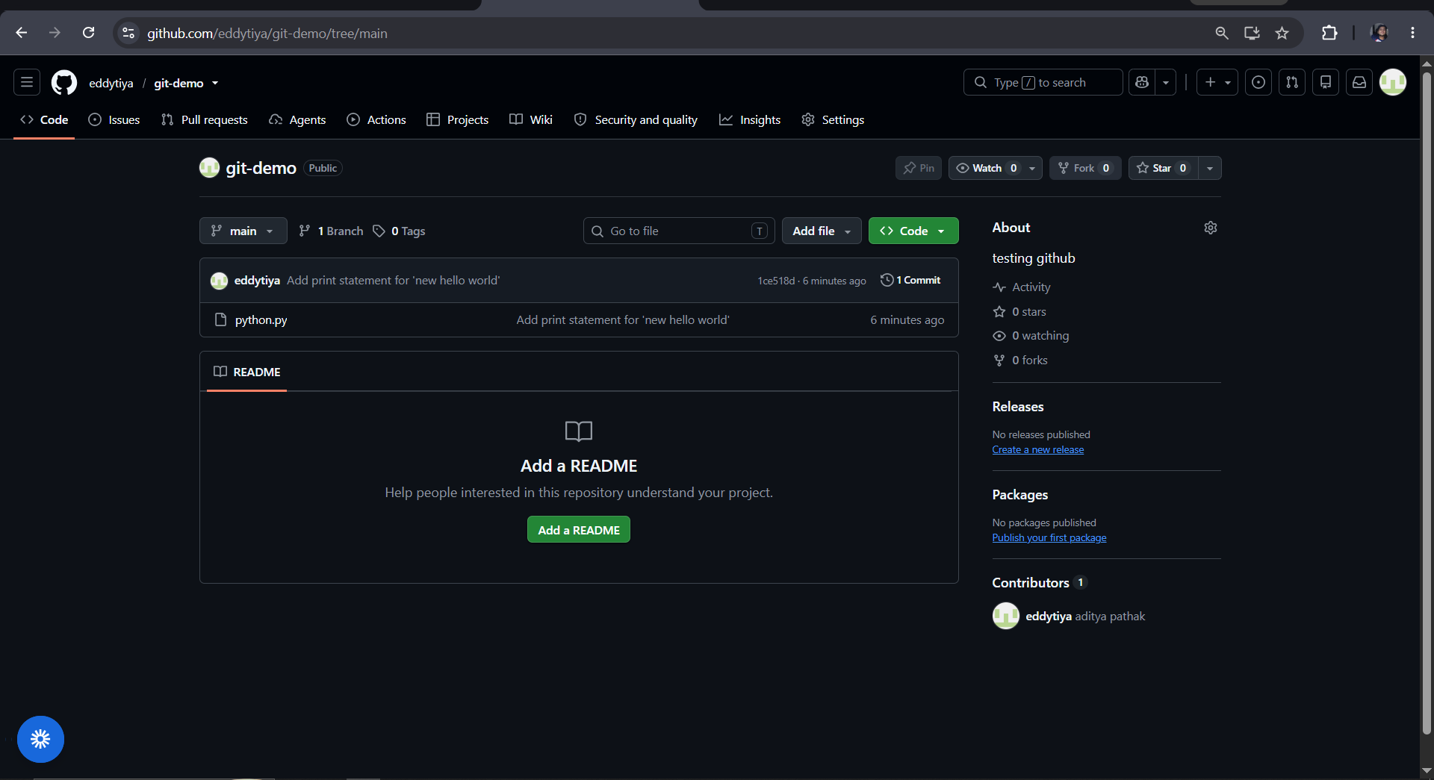

Create a new repo
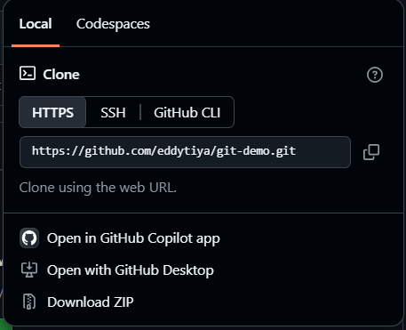

To clone this
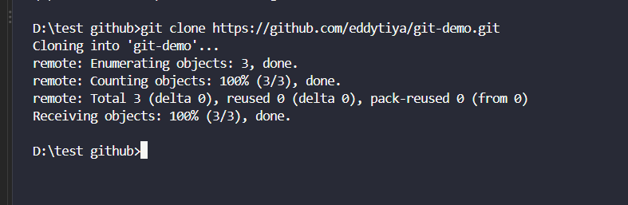

NOTE:do not git init when cloning
Cd into the new branch
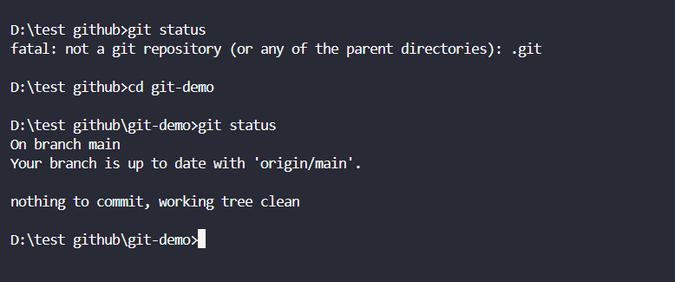

Add new file and now we are pushing it to the github the changes

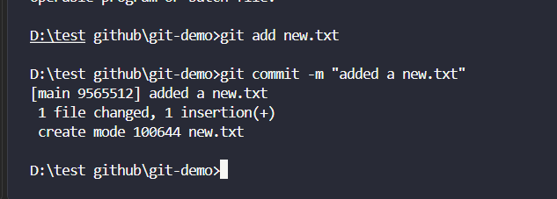

But no changes still cause we have just locally made changes
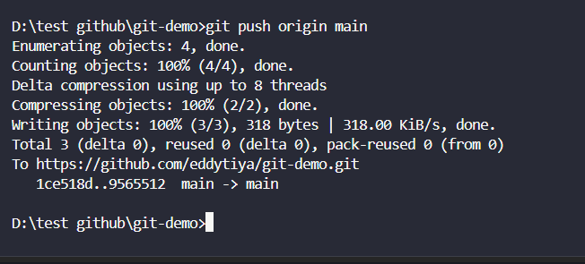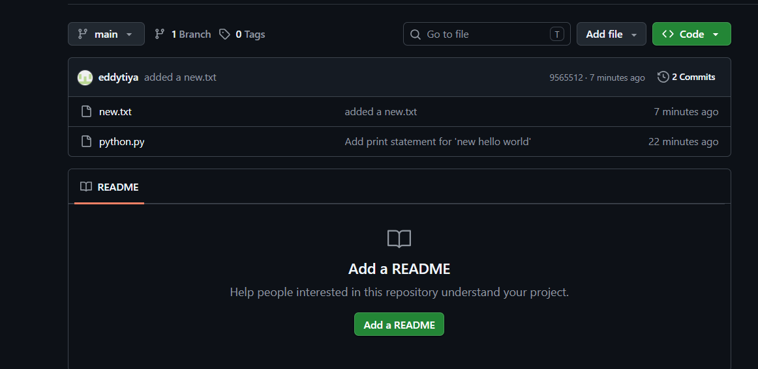

Now suppose there are more changes made to the github repo
